**CLC**

**Intermediate Cadet Leadership Course**

**“Challenger”**

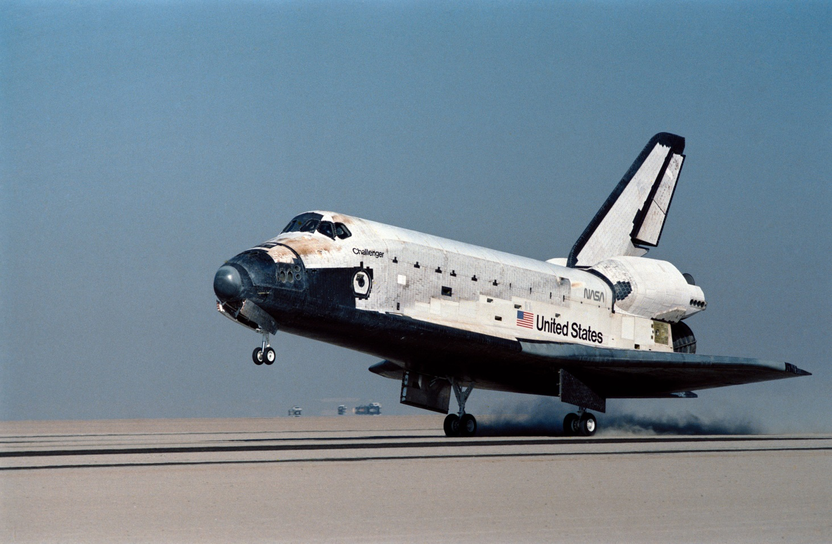

**Cadet Study Guide**

**University of Houston**

**2022**

**NOTE: All Advanced CLC (“Endeavour”) cadets will use this guide as a resource to lead their units**

Congratulations on your selection to attend “Challenger” Intermediate Cadet Leadership Course (CLC). This is certainly an achievement of which you should be proud. As such, your selection was based on your potential to excel as a cadet, and as a person in your JROTC unit, high school, and community. With this in mind, your instructors communicated to course leadership you are among the best and brightest cadets at your JROTC unit and will play a pivotal role in the next semester’s leadership. Therefore, upon your arrival and until your departure you are expected to conduct yourself in the manner appropriate for a future leader in your Cadet Corps; you are held to the highest standards that your instructors and Challenger staff expect of a future leader. **All material in this study guide is testable! Please note that flight commander, deputy commander and guide responsibilities will be rotated on a daily basis from within the Challenger flights. Cadets attending this course should be prepared and trained to assume those roles.**

**NOTE: All Advanced Cadet Leadership Course (“Endeavour”) cadets will use this guide to help teach/train their units.**

**Safety**

You must take a full hydration system wherever you go when you leave your dormitory. At every meal, you must drink at least one full glass of water.

You must have a partner (wingman) of the same gender when you transit out of the dormitory area to a different location. In addition, you must notify someone (flight/dorm mates) of where you are going. Accountability is paramount to success.

Cadets may only travel in details of the same gender. If cadets are leaving the common area (where cadets are training) they must notify the cadet training officer (CTO) why they are leaving and where they are going.

You must wear closed toe shoes (tennis/running shoes, etc.) at all times when outside your room. During fire drills, cadets MUST wear athletic shoes; no other closed toe shoe is authorized. Exceptions are made in specific circumstances such as sand volleyball.

You must use the handrails when transiting up and down stairs.

Cadets will not walk on the grass unless given permission from the CTO or other assigned personnel.

**Cadet Behavior and Conduct**

The following expected behavior of cadets is critically important to the success of this course. While this document is not all inclusive, it sets the minimum standards for behavior and discipline at the Intermediate Cadet Leadership Course.

**Respect for instructors, cadet training officers (CTOs), and cadet trainees**: All instructors, CTOs, and cadet trainees deserve to be treated with respect and dignity. While this course is expected to be very challenging for cadets; hazing, the use of exercise for punishment, sexual harassment, profanity or any language that demeans or belittles cadets in any way will not be tolerated. The Commandant of the Cadet Leadership Course is the final authority regarding any infractions committed at the camp and the removal or dismissal of any cadet from the camp.

**Public display of affection:** Cadets will not participate in any public display of affection. While a brief hug between cadets expressing joy that one or both have won a competition is acceptable, hugging, kissing, holding hands, and other methods of displaying affection are not acceptable behaviors.

**Sexual Harassment and/or Hazing:** Sexual harassment of any type is prohibited. Any type of hazing or treatment that demeans an individual will not be tolerated. Such behavior degrades the team and the individual and will result in dismissal/removal from the course.

**Use of drugs, alcohol, and tobacco:** Drugs, alcohol, and tobacco are strictly prohibited at ICLC. The use of these products by minors is a crime. Appropriate authorities (University of Houston campus police) will be notified and the cadet trainee will be dismissed from the ICLC.

**Electronic devices:** Electronic devices are not permitted in the possession of cadet trainees. Do not bring cell phones, radios, iPods, or any other electronic devices with you. You will not have time for these items and they are easily broken, lost, or stolen. Instructors may allow cadets the opportunity to call home once they have safely arrived at the University of Houston (UH). Other items of contraband include food, beverages other than water, any medications (except an inhaler for asthma), drugs, alcohol, etc. Your instructor will keep your parents advised of your progress at school. He/she will also insure your parents have his/her cell phone number in case of an emergency, such as a death in the family. However, if your parents cannot reach your instructor they may call the school at the emergency numbers listed in the Emergency Contact Information section of this guide.

**Lights out:** Lights out is at 2200 hours every night. All cadet trainees will be in their rooms at 2200 hours each night with the lights out. Violations of this policy will be cause for disciplinary action. Random room checks will be the norm to ensure compliance.

**Off limits:** Instructor rooms, store rooms and administrative offices, buses, and privately owned vehicles are off limits to all cadet trainees. Opposite sex dormitory rooms are also off limits—violations will be cause for immediate dismissal from the course. Cadets will also be with a “wingman” cadet anywhere they go. At a minimum you will always travel in pairs when not in formation. Any violation of this policy will result in disciplinary action and/or dismissal from the ICLC.

**Absences and tardiness:** All cadet trainees must be present at all formations/events (PT, drill practice and drill tests, academic classes and tests, etc.). CTOs will have a roll sheet listing all cadets and their room numbers in your flight. You are each held accountable for ensuring all cadets from your flight are present at all formations/events. If you have a cadet not present, you will notify their CTO or assigned instructor immediately. They will in turn contact the CQ who will then notify the cadet’s SASI or ASI and the school Commandant. Only medical issues will be reason to miss a formation or event. Cadets who miss an entire formation/event may be allowed to continue on a case by case basis, but will not be considered for honor, distinguished, or other graduate awards.

**Emergency Contact Information**

1. **Units with “Challenger” cadets must have a SASI or ASI accompany their cadets the entire time the unit is attending CLC.** Each cadet will provide their SASI/ASI contact information (phone number) to the parents/guardians of each cadet attending. **Your school’s instructor is your parents’ first point of contact!**

2. The cadet leadership course also has a 24 hour contact point at the University that can relay information to the Charge of Quarters (CQ), located in Cougar Village. **Parents should use the following emergency phone number ONLY if they are unable to contact their cadet’s instructor: (713) 743-6000.** Inform the person who answers you have an emergency message for your cadet at the AFJROTC Cadet Leadership Course.

3. If unable to contact any of the above numbers, contact the UH campus police department at (713) 743-2255 and tell them you need to make contact with the CQ for the JROTC, Cadet Leadership Course, located in Cougar Village.

**Dress and Personal Appearance**

**Service Uniform (Males)**

Flight Cap—wear the cap tilted slightly to your right, with the vertical crease in line with the center of the forehead, in a straight line with the nose, approximately 1 inch above the eyebrows. Do not crush the crown, front, or back of the cap.

Short Sleeve Blue Shirt—must touch, or come within 1 inch of touching, the forearm when the arm is bent at a 90-degree angle. Do not press military creases into the shirt. Shirts must be neatly tucked into the trousers. Wear a white V-neck undershirt with the blue shirt.

Ribbons—centered and flush above the left breast pocket.

Name Tag—centered and flush above the right breast pocket.

Trousers—dark blue, full cut, straight hanging and without a cuff. Trousers are trim fitted with no bunching at the waist or bagging at the seat. The front of the trouser leg must rest on the front of the shoe, with a slight break in the crease. The back of the trousers must be approximately 7/8 of an inch longer than the front.

Belt—dark blue, woven. The tip and buckle of the belt must have a chrome-like finish. The tip of the belt extends beyond the buckle, facing the wearer’s left. No blue fabric will show between the buckle and the belt tip. You must have a visible and aligned gig line—this is the line that runs down the right front edge of your shirt, belt buckle, and fly.

Low Quarters/Oxfords—black, leather, issue type, with plain rounded toe only. They must be kept in good repair at all times and have a gloss shine.

Socks—must be plain black. Wear is mandatory.

**Service Uniform (Females)**

Flight Cap—worn tilted towards the wearer’s right, with the vertical crease at the center of the forehead in a straight line with the nose, approximately 1 inch above the eyebrows.

Short Sleeve Blue Blouse—must touch, or come within an inch of touching, the forearm when bent at a 90-degree angle. Do not press military creases into the blouse. Tuck-in-style blouses have a pointed collar with epaulets. These blouses must be tucked into the slacks.

Ribbons—center on left side between buttons and arm seam. The bottom of the ribbons is even with the bottom of the name tag.

Name Tag—centered on right side even with or up to 1 ½ inches higher/lower than the first exposed button.

Slacks—dark blue, straight hanging, with two front pockets, a center fly front opening, and belt loops. The front of the slack leg rests on the front of the shoe with a slight break in the crease. The back of the slacks will be approximately 7/8 of an inch longer than the front.

Belt—dark blue, woven. Wear with skirts and slacks having belt loops. The belt must have a chrome-like finish. The tip of the belt must extend beyond the buckle facing the wearer’s right. No blue fabric may show between the buckle and the belt tip. You must have a visible and aligned gig line—this is the line that runs down the left front edge of your shirt, belt buckle, and fly.

Socks/Hosiery—Wear of hose with the blue skirt is mandatory. You may wear hose or socks when wearing slacks. Socks must be plain black. Hose will be commercial sheer nylon. Colors may be neutral, dark brown, black, off black, or dark blue shade. Patterned hose will not be worn.

Shoes—Low Quarter (Oxfords)—black, leather, issue type, with plain rounded toe only. They must be kept in good repair at all times and have a gloss shine. **Pumps are not allowed at CLC.**

**Customs and Courtesies**

**Addressing CLC Staff**

All cadets attending CLC will refer to the CTOs as CTO Last Name (e.g., “Good Afternoon CTO Smith”). When cadets address officers or enlisted personnel, they will use their rank and last name (e.g., “Good Afternoon Master Sergeant Smith”). If the cadets do not know the name of the individual addressing them, they will use “Sir/Ma’am.”  **DO NOT** use the “Sir/Ma’am Sandwich” (e.g., “Sir, Good Morning Sir).

**Greetings and Salutes**

Cadets are required to exchange salutes when in the blue Service Uniform with all CTOs who have black and silver rank insignia, as well as military officers of any branch of service. At no time will a cadet turn their upper body to salute someone behind them nor will they salute someone they approached from the rear. If in a classroom and a SASI, active duty officer, or a CTO enters, call the room to attention. Once classroom instruction begins, only call the room to attention if an O-6 (Colonel) or above enters the room.

Cadets will render proper greetings of the day to the CTOs, active duty, and JROTC personnel at all times. Unless cadets are in the classroom for instruction or in formation, all cadets will use the proper greeting of the day. When in formation, the Cadet Flight Commander will render a salute if applicable and simultaneously greet on behalf of the formation. The greetings of the day are as follows:

0000-1159 = “Good Morning, Sir/Ma’am”

1200-1659 = “Good Afternoon, Sir/Ma’am”

1700-2359 = “Good Evening, Sir/Ma’am”

**Saluting Courtesies to the U.S. Flag**

When outdoors and in uniform, as the U.S. flag passes by, stand at attention, salute six paces before the flag passes you and hold your salute until the flag is six paces past you. Females do not have to remove their hats. Flags on stationary flagstaffs are only saluted during Reveille, Retreat, or special ceremonies.

**Exceptions to Saluting**

There are several exceptions to saluting. The following situations do not address every possible situation. Exercise good judgment when confronted with all situations.

- If your arms are full, you don’t have to salute; simply extend a verbal greeting. Always try to keep things in your left hand if possible so you can salute.

- If an officer’s hands are full, but yours are not, extend a verbal greeting and salute. Once the officer acknowledges your salute or passes you, drop your salute.

- Do not salute indoors, except during formal reporting, and during some ceremonies.

- Salutes are not required if either person is in civilian clothing. You may salute if you recognize the officer.

**Reporting Statements**

Cadets will use reporting statements at ALL times. In order to raise the hand, the hand must be in a fist (similar to the position of Attention) with the thumb to the back, extended vertically with the elbow almost locked, and perpendicular to the ground. *This will be demonstrated at CLC.

“Sir/Ma’am, Cadet __________ reports (as ordered, to ask a question, etc.).”

**Knowledge**

Basic Knowledge will consist of questions related to general Air Force information. This may include Air Force chain of command (from the President through the AF JROTC Director), drill and ceremonies, dress and appearance, rank and structure, history, and organization (the Major Commands and where their headquarters are located).

During uniform inspections, instructors/CTOs will ask questions in order to determine a cadet's poise, confidence, and knowledge of the subject in the previous paragraph. They will also ask questions they do not expect the cadet to answer correctly. Cadets must not become flustered or lose their military bearing! If a cadet does not know the answer to any question, a strong, “Sir/Ma’am, this cadet does not know,” or similar response, is best.

**Drill and Ceremonies**

Drill consists of certain movements by which the flight or squadron is moved in an orderly manner from one formation to another or from one place to another. Standards such as the 24-inch step, cadence of 100 to 120 steps per minute, distance, and interval have been established to ensure movements are executed with order and precision. Individuals must learn to adapt their own movements to those of the group in accordance with Air Force Manual 36-2203.

If transiting and not in a flight (5 or more), cadets must transit in details at all times. A **detail** consists of 2 to 4 cadets. Details are marched by the individual in the back right corner. If it is necessary to salute, all cadets in the detail will salute and greet, not just the person marching the detail.

Use proper command voice. Do not “bark” commands. See AFMAN 36-2203 for reference.

Cadets cannot put their flights “At Ease,” unless instructed to do so by a SASI/ASI/CTO.

If it is necessary to cross rough terrain, cadets will use “Route Step, March” and call the flight back to attention upon returning to suitable terrain.

Cadets must know how to execute “Column of Files,” as this will be used to enter the dining facility and academic building.

Cadets must know “Open Ranks” inspection procedures; several will be conducted during the course.

**Definitions**

The following are the most common terms referred to when teaching, demonstrating, and executing drill.

**Alignment**: dress or cover.

**Base**: the element on which a movement is planned, regulated, or aligned.

**Cadence**: the uniform step and rhythm in marching; that is, the number of steps marched per minute.

**Center**: the middle point of a formation. On an odd-numbered front, the center is the center person or element. On an even-numbered front, the center is the right (as viewed from within the formation) center person or element.

**Cover**: individuals aligning themselves directly behind the person to their immediate front while maintaining proper distance.

**Depth**: the total space from front to rear of any formation. An individual’s depth is considered to be 12 inches.

**Distance**: the space from front to rear between units. The distance between individuals in formation is 40 inches as measured from their chest to the backs of individuals directly in front of them. Flight commanders, guides, and others whose positions in formation are 40 inches from a rank are themselves considered a rank.

**Double** **Time**: the rate of marching at 180 steps (30 inches in length) per minute

**Dress**: alignment of elements side by side or in line maintaining proper interval.

**Element**: the basic formation; that is, the smallest drill unit comprised of at least 3, but usually 8 to 12 individuals, one of whom is designated the element leader.

**File**: a single column of persons placed one behind the other.

**Final** **Line**: the line on which the adjutant forms the front ranks of troops for a parade or review.

**Flank**: the extreme right or left (troops’ right or left) side of a formation in line or in column.

**Flight**: at least two, but not more than four, elements.

**Formation**: an arrangement of units.

**Front**: the space occupied by a unit, measured from flank to flank. The front of an individual is considered to be 22 inches.

**Guide**: the airman designated to regulate the direction and rate of march.

**Head**: the leading unit of a column.

**In** **Column**: the arrangement of units side by side with guide and element leaders to the head.

**In** **Line**: the arrangement of units one behind the other with the guide and element leader to the extreme right flank.

**Interval**: the space between individuals placed side by side. A normal interval is an arm’s length. A close interval is 4 inches.

**Inverted** **Column**: the arrangement of units side by side with guide and element leaders to the rear.

**Inverted** **Line**: the arrangement of units one behind the other with the guide and element leaders to the extreme left flank.

**Line** **of March:** a line followed by troops as they pass in review.

**Mark** **Time**: marching in place at a rate of 100 to 120 steps per minute.

**Mass** **Formation**: the formation of a squadron or group in which the component units are in column, abreast of each other, and at close interval.

**Pace**: a step of 24 inches. This is the length of a full step in quick time.

**Post**: the correct place for an officer, noncommissioned officer (NCO), or airman to stand while in formation.

**Quick** **Time**: the rate of marching at 100 to 120 steps (12 or 24 inches in length) per minute.

**Rank**: a single line of persons placed side by side.

**Ready** **Line**: a forming line 20 paces to the rear of the final where the troops are formed for a parade or review at an established time prior to adjutant’s call.

**Reviewing** **Officer**: the senior officer participating in a parade or review.

**Slow** **Time**: the rate of marching at 60 steps per minute (used in funeral ceremonies)

**Step**: the distance measured from heel to heel between the feet of an individual marching.

**Unit**: any portion of a given formation.

**Types of Commands**

A drill command is a verbal order. Most drill commands have two parts, the preparatory command and the command of execution. The preparatory command explains what the movement will be. When calling a unit to attention or halting a unit’s march, the preparatory command includes the unit’s designation. In the command “Flight, **HALT**,” the word “Flight” is the preparatory command. At the same time, it designates the unit being addressed.

The command of execution follows the preparatory command. The command of execution explains when the movement will be carried out. In “Forward, **MARCH**,” the command of execution is “**MARCH**.”

In certain commands, the preparatory command and the command of execution are combined, for example: “**FALL IN**,” “**AT EASE**,” and “**REST**.” The commands are given at a uniformly high pitch and a louder volume than a normal command of execution.

Supplemental commands are given when one unit of the element must execute a movement different from the other units or must execute the same movement at a different time. Two examples are “**CONTINUE THE MARCH**” and “**STAND FAST**.”

Informational commands have no preparatory command or command of execution and they are not supplementary. Two examples are “**PREPARE FOR INSPECTION**” and “**DISMISS THE SQUADRON**.”

**Flight Commanders**

Prior to marching a flight, the commander must follow proper guidelines to ensure the flight is sized appropriately and are prepared to conduct drill and ceremonies. The following procedures should be accomplished in normal drill and ceremony situations; however, they may be modified for drill competition or evaluations.

The first command is “**FALL IN**.”

On this command, the guide takes a position facing the flight sergeant and to the flight sergeant’s left so the first element will fall in centered on and three paces from the flight sergeant. Once halted at the position of attention, the guide performs an automatic dress right dress. When the guide feels the presence of the first element leader on his or her fingertips, the guide executes an automatic ready front. Once positioned, the guide does not move.

The first element leader falls in directly to the left of the guide and, once halted, executes an automatic dress right dress. The second, third, and fourth element leaders fall in behind the first element leader, execute an automatic dress right dress, visually establish a 40-inch distance, and align themselves directly behind the individual in front of them. The remaining airmen fall into any open position to the left of the element leaders and execute an automatic “dress right, dress” to establish dress and cover.

To establish interval, the leading individual in each file obtains exact shoulder-to-fingertip contact with the individual to his or her immediate right. As soon as dress, cover, interval, and distance are established, each airman executes an automatic ready front on an individual basis and remains at the position of attention.

Once it is formed, the flight will be squared off prior to sizing. The left flank of the formation will be squared off with extra airmen filling in from the fourth to the first element. For example, if there is one extra airman, he or she will be positioned in the fourth element; if there are two extra airmen, one will be positioned in the third element and one will be positioned in the fourth element; and so forth.

To size the flight, the flight commander faces the flight to the right (from line to column formation) and has taller personnel (except the guide, element leaders, and flight sergeant) move to the front of the flight according to height. The flight commander then faces the flight to the right (from column to inverted line formation) and again has taller personnel (except the flight sergeant) move to the front of the flight according to height. The flight commander faces the flight back to the left (column formation) and continues this procedure until all members are properly sized.

Each member of the flight has a number except the guide. Numbering of individual members of a flight is from right to left (when in line formation) and from front to rear (when in column formation). The element leader is always number one.

**Formal Drill Competition**

Cadets must know how to drill and know drill terminology. Flights will perform 30-Step drill sequence for competition.

The 30-step Flight Drill Evaluation Sheet is on the next page. All ICLC cadets must be able to execute all movements with snap and precision. A score of 0 means failure to execute the maneuver or unsatisfactory execution, 5 represents satisfactory execution (some mistakes), and 10 represents outstanding execution (no mistakes of any kind). The flight will also be graded on their military bearing as well as sharpness during execution.

The Flight Commander will be graded on proper command voice, their command presence (reflected in the sharpness or “snap” in the flight), and military bearing. The commander is responsible for ensuring proper completion of the sequence. In the event a flight ties another flight, the Flight Commander’s score and notes will be used to break the tie.

|  |
| --- |
|  |

**30-step Drill Sequence**

**“FALL IN”**

A flight forms in at least two, but not more than four, elements in line formation. On the command, the guide takes a position facing the flight commander and to the left so the first element will fall in centered on, and three paces from, the flight commander. Once halted at the position of attention, the guide performs an automatic “dress right, dress.” When the guide feels the presence of the first element leader on their fingertips, the guide executes an automatic “ready, front.” The first element leader falls in directly to the left of the guide and executes an automatic dress right dress. The second, third, and fourth element leaders fall in behind the first element leader, execute an automatic dress right dress, visually establish a 40-inch distance, and align themselves directly behind the individual in front of them. The remaining airmen fall into any open position to the left of the element leaders and execute an automatic dress right dress to establish dress and cover.

“Open Ranks**, MARCH”**

Only given to a formation when in line at normal interval. Once halted, the distance between ranks will be 70 inches.

“Ready, **FRONT”**

The flight commander marches three paces beyond the front rank, halts, and faces to the left (down line).

“Close Ranks**, MARCH”**

“Present**, ARMS”**

“Order, **ARMS”**

“Parade **REST”**

“Flight**, ATTENTION”**

“Left, **FACE”**

“About, **FACE”**

Individuals align themselves directly behind the person to their immediate front while maintaining proper distance. Command can be executed anytime the flight is halted.

“Forward, **MARCH”**

“Right Flank, **MARCH”**

“Left Flank, **MARCH”**

“Column Right, **MARCH”**

“Forward, **MARCH”**

“To the Rear, **MARCH”**

“To the Rear, **MARCH”**

“Column Right, **MARCH”**

“Forward, **MARCH”**

“Eyes, **RIGHT”**

The preparatory command and the command of execution are given on the right foot while marching. On the command **RIGHT** all persons, except those on the right flank, turn their heads and eyes smartly 45 degrees to the right.

“Ready, **FRONT”**

The command is given as the left foot strikes the ground. On the command **FRONT,** heads and eyes are turned smartly to the front.

“Column Right, **MARCH”**

“Forward, **MARCH”**

“Change Step, **MARCH”**

On the command **MARCH,** given as the right foot strikes the ground, the cadet takes one more 24-inch step with the left foot. Then in one count, place the ball of the right foot alongside the heel of the left foot, suspend arm swing and shift the weight of the body to the right foot. Step off with the left foot in a 24-inch step, resuming coordinated arm swing. The upper portion of the body remains at the position of attention throughout.

“Column Right, **MARCH”**

“Forward, **MARCH”**

“Flight, **HALT”**

“Left, **FACE”**

“Right Step, **MARCH”**

Command is given only from the halt and for moving short distances. On the command, March, the cadet raises the right leg from the hip just high enough to clear the ground. The leg will be kept straight, but not stiff, throughout the movement. The individual places the right foot 12 inches, as measured from the inside of the heels, to the right of the left foot. Transfer the weight of the body to the right foot, then bring the left foot (without scraping the ground) smartly to a position alongside the right foot. The upper portion of the body remains at attention and arms remain at the sides throughout. Cadence may be counted. Counts 1 and 3 are given as the right foot strikes the ground. Counts 2 and 4 are given as the heels come together.

“Flight, **HALT”**

To halt, the preparatory command and command of execution are given as the heels come together. On the command, “**HALT,”** one more step is taken with the right foot and the left foot is placed smartly alongside the right foot as in the position of attention.

**Daily Activities, Procedures, and Protocol**

You are expected to be able to perform these activities or comply with the following instructions at any given time. Remember, it is your responsibility and **duty** to lead and direct your flight. **Failure to comply is grounds for removal from your leadership position.**

**Road Guard Procedures**

Cadet Flights **must** use Road Guard procedures to cross the road **at all times.**

Unless otherwise directed, cadets will not piggyback units (march more than one unit across the street without allowing traffic to proceed between them) when crossing streets.

For safety reasons, flights will **always** be halted prior to entering a hazard area so the Cadet Flt/CC can ensure safety while posting road guards. The Cadet Flt/CC will ask permission of the staff member escorting them to cross roads or enter the hazard areas. The Cadet Flt/CC will move forward and post in front of the flight at the sidewalk/hazard edge. The Cadet Flt/CC will wave traffic past OR motion for the traffic to stop by extending either arm and displaying the palm of the hand with the fingers pointed upward. The Cadet Flt/CC will then march into the intersection and post in the middle of the road, perform an about face (so they‘re facing the flight), ensure traffic is stopped and command, **“ROAD GUARDS OUT.”** On the command, **“ROAD GUARDS OUT,”** the left road guard will go to the closest lane, and the right road guard will go to the farthest lane, face oncoming traffic at parade rest with the right arm up, palm flat with the fingers pointed upward. If carrying a flashlight, road guards will hold the flashlight in the extended arm with the beam pointed down. The Cadet Flt/CC will command the flight to march across the intersection and perform the necessary facing movements so they can observe the flight at all times. Once the flight is through the intersection, the Cadet Flt/CC will halt the flight and command, **“ROAD GUARDS IN.”** The Cadet Flt/CC will remain in the intersection and continue to halt existing traffic while the road guards return to the rear of the flight. The Cadet Flt/CC does not give further commands (e.g., “Forward **MARCH”**) until rejoining the flight.

**Dining Facility/Academic Building Procedures**

Cadets will use the “Column of Files” command in order to enter the Dining Facility and Academic Buildings. Once a cadet enters the doorway of the facility, they do not need to march or call commands, but will proceed briskly in a military fashion to their destination.

There will be **no talking** in the academic building hallways.

Cadets are expected to have a “tight meal” posture during all meals in the dining facility. This means cadets will sit at the position of attention and **not talk or look around.**

**Dormitory Procedures, Protocol, and Guidelines**

**General Dormitory Information**

Dorms will be kept clean, neat, and in order at all times. **Any additional items not specified in the Dormitory Room Requirements section below are expected to be stored out of the way in a neat and tidy manner.**

Dorm common areas will be neat and clean at all times. Cadets are **not** allowed to use the furniture in the common area or chairs in their rooms until Individual Cadet Time (ICT) or Change to Quarters (CTQ).

Doors to each bedroom and each wing of the dormitory will remain open at all times, with the exception of when cadets are changing and during sleeping hours. During those times, only the doors to the bedrooms will be closed. Blinds will remain closed at all times. The main door into the dormitory will be locked at all times.

Before entering a room occupied by members of the opposite gender, cadets and staff members will announce, “Male/Female in the area,” and wait for the appropriate response. The cadet closest to the entrance will confirm that all cadets in the area are properly dressed and respond, “Please Standby” if any member is not properly dressed and, “All Clear” as soon as appropriate. Cadets **will not** change clothes in the presence of members of the opposite gender.

**Dorm Room Requirements**

Rooms should be inspection ready from the end of the first dorm maintenance period until the beginning of Individual Cadet Time (ICT). Wastebaskets must be completely empty during formal inspections.

Chairs should be pushed all the way in unless being used during ICT/CTQ.

Turn off all lights when not in use and ensure water is not running when not actively in use. If there is a leak, notify a staff member immediately. **DO NOT** open windows at any time unless directed to do so.

Latrines, commodes, urinals, sinks, showers, and drying areas will be kept clean and dry. Toilet seats will be displayed in the up position for both male and female latrines. Toilet tissue will be neatly rolled, i.e., not hanging down. Latrine doors will be opened 90 degrees when not in use.

Upon arrival cadets will rotate by flight to visit the model room. It is imperative that cadets take accurate notes and ask questions. The model room will be used in the evaluation of cadet rooms during the room inspections.

**White Collar Bed:** Used during formal inspections and the duration of CLC.

(1) Bottom (First) Sheet. Drape evenly over width of mattress. Ensure the bottom edge of sheet is flush with the foot end of mattress. Tuck excess under at the head end of mattress. Make hospital corners.

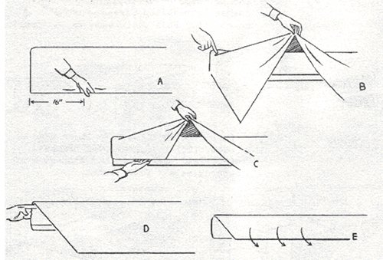***NOTE:*** Making hospital corners. (A) Grasp the side of sheet approximately 16 inches from the head end of mattress. (B) Lay the sheet on top of the mattress, creating a 45-degree angle. (C) Tuck excess material hanging down under mattress. (D) Next grasp 45-degree angle and without changing its shape, bring it down and (E) tuck under mattress. After sheet is completely tucked, smooth and tighten to the conformity of mattress.

(2) Top Sheet. Drape evenly over width of mattress so that the top edge of the sheet is approximately 6 inches from the head end of the mattress. Tuck excess under the foot end of mattress. Do not make hospital corners on this sheet yet!

(3) Drape the blanket evenly over the width of the mattress, with the end of blanket approximately six inches from the head end of mattress. Tuck the excess blanket under the foot end of mattress. Make hospital corners with both the sheet and the blanket, together, at the foot end. Tuck remainder of sheet/blanket under mattress. Smooth and tighten to conform to the mattress shape.

(4) White Collar. Fold the top sheet and blanket over together to form a six inch white collar and then fold again, so that the bottom of the six-inch collar is 24 inches from the head end of the mattress. Tuck remaining material hanging on the sides neatly under the mattress, including white collar. After the blanket and sheet are completely tucked, smooth and tighten to conform to the mattress shape.

(5) Pillow and Pillowcase. Put pillow inside case. Center the length of the pillow on the width of the mattress, flush with the head end of the mattress. The open end of pillow case faces away from the inspection side with the excess material neatly folded underneath.

(6) Mattress. Center the mattress on the bed frame and ground to (push against) the head end of the bed.

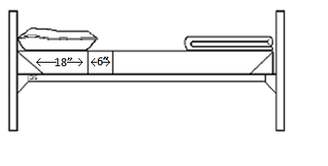

**Closet:**

**a. General Instructions**: Keep the closet clean and dust free. Prior to inspection, ensure that your closet door is completely open. Keep all items clean, dry, pressed, folded, serviceable, and displayed appropriately. Inform your chain of command if an item becomes unserviceable. Remove all strings and tags (except sewn-in tags). Ensure all pockets are empty. Display items **as worn** (zipped, snapped, buttoned, pressed, etc.), unless otherwise directed. Hang all items separately; e.g., no pants and shirts combined on the same hanger. **Closet arrangements will be the same for both occupants of a room—do NOT “mirror-image” them.**

**b. Hanger Management**

(1) Hang all hangers with the open end of hook facing toward the rear of the closet.

(2) Hang all sleeved items with the left sleeve (school patch) facing the door (out) of the closet.

(3) Trousers must be hung with the waistband on the right and the zippers facing out.

(4) Space hangers with clothing on them evenly between the left wall and the right wall of closet. The space between the left wall and first hanger, and between the last hanger and right wall, is equal to the space between all other hangers.

**c. Extra Hanger Management**

(1) No more than three extra hangers are authorized for display in the closet. These hangers

should be used for replacement purposes, or for items being worn or laundered.

(2) Display all extra hangers as one, grounded to the left wall, and consider them as part of the wall itself (do not space extra hangers out).

**d. Hanging Arrangement**

All uniform items will be displayed shirts to the left, pants to the right. Number of shirts must match number of pants (e.g. if two shirts are displayed, they will be to the left of two pairs of pants). If uniform items are being worn, do not display the empty hangers in their place. Place the empty hangers with the extras, grounded to the left wall (not to exceed three hangers) or stow them out of view.

**e. Closet Shelf**

Place the front of the flight cap flush with the front edge of the shelf and against the right wall, with the triangle facing down.

**f. Floor Items/Shoe Display**

Keep all shoes clean, dry, shined, serviceable, and displayed as applicable. If changing shoes, place the shoes that were worn back in the closet in the appropriate order of display, laced, with excess laces on all shoes tucked inside the shoes, out of sight.

Shoes will have the heels grounded to the right wall, toes pointing left. The edge of the shoe furthest from the door will be grounded to the back wall. All shoes will be grounded (edges/sides touching) to each other. If a pair of shoes is being worn, the remaining shoes will be grounded to each other—do not leave an empty space for the pair being worn. The shoes closest to the front of the closet (if not being worn) are low quarters, followed by running shoes, then shower shoes.

**Lacing Shoes (Low Quarters and Running Shoes)**: Make a bar at bottom of the shoe by lacing from the outside to the inside through the bottom eyelets. Continue lacing the shoe from the inside to the outside all the way to the top. Tuck the excess laces inside the shoe, out of sight.

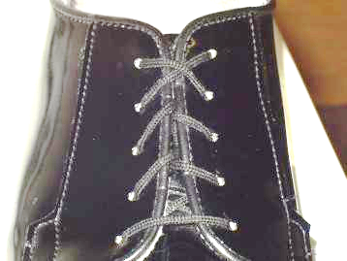

How to properly lace shoes for display—excess laces tucked inside shoe, out of sight

**Luggage:** Luggage will be grounded to the back left corner of the closet.

**Laundry bag:** Store only dirty clothes, towels, and washcloths inside the laundry bag. Wet items must be placed inside a plastic bag (secured at the top) prior to putting the item in the laundry bag. A plastic bag will be a clear, white, black, or brown trash bag. Pull the laundry bag strings tight so the top of the bag is closed. Any excess at the top of the bag and strings will be tucked towards the corner neatly. Display on the floor grounded to the front left corner.

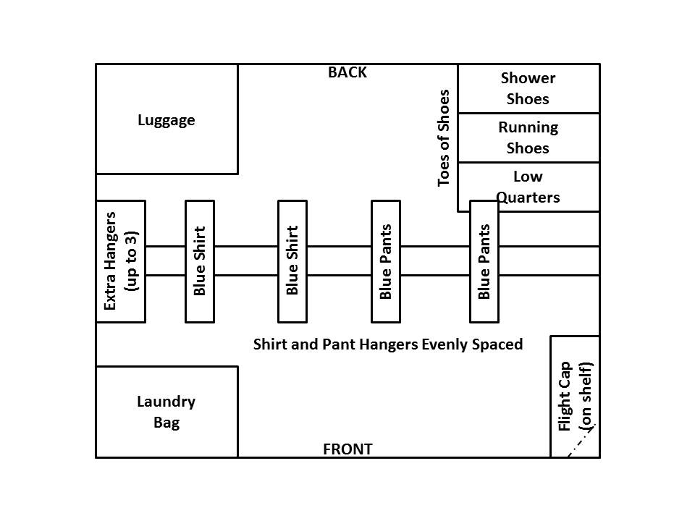

Diagram of closet layout. **Both closets in the room must match!**

**g. Drawers**

The layout for drawer organization will be demonstrated in the Model Room upon arrival to CLC. It is imperative that you pay close attention to the display.

(1) The top drawer is the Clothing Drawer. All undergarments, socks, T-shirts, and shorts will be in this drawer. NOTE: The first item of each type (e.g., socks) should be grounded to the front of the drawer and subsequent items of the same type (e.g., socks) grounded to each other behind the first item.

(2) The middle drawer is the Hygiene Drawer. Items needed to maintain personal hygiene will be in this drawer: toothbrush, toothpaste, soap, shampoo, shaving kit, washcloths, etc. NOTE: The first item (e.g., toothbrush) must be grounded to the front of the drawer and subsequent items (e.g., toothpaste) should be grounded to each other.

(3) The bottom drawer is the Personal Items Drawer. It must be kept organized and clean. This drawer will have any other items that do not classify into the other drawers (e.g., hair spray, study materials, towels (dry), etc.).

**T-Shirts:**

(1) Rolled with the open edge down, single fold to the left. Place shirts in one row from the front of the drawer to the back, stacking if necessary.

(2) Ground PT T-shirts to the front left corner of the drawer, as you are looking into the drawer.

(3) Ground white T-shirts (optional for females) to the front of the drawer and to the right of the PT T-shirts.

**Instructions for Rolling T-shirts (White/PT)**

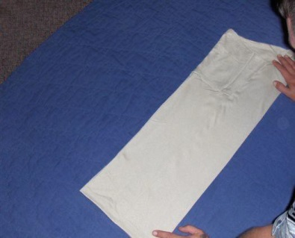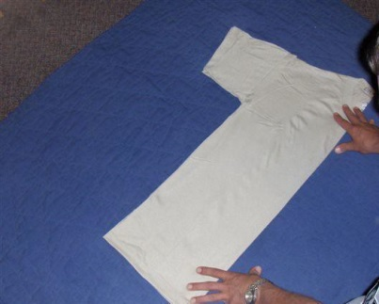

a. Lay the T-shirt flat. Ensure edges are even. Fold b. Fold the sleeves in so the shirt

the shirt in half lengthwise, down the middle of the shirt. forms a rectangle.

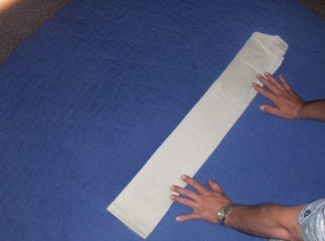

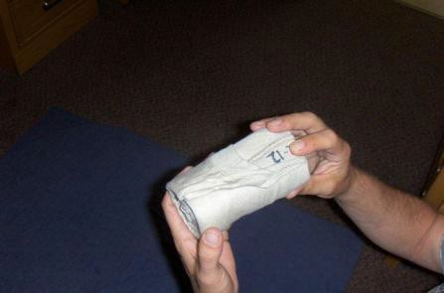

c. Fold the T-shirt in half lengthwise again. d. Tightly roll the T-shirt starting

from the waist toward the collar.

When properly folded and rolled, single folds will be on the left side with edges as even as possible.

**Instructions for Rolling Underwear/ PT Shorts**

Rolling will be the same for all types of underwear and shorts for both genders.

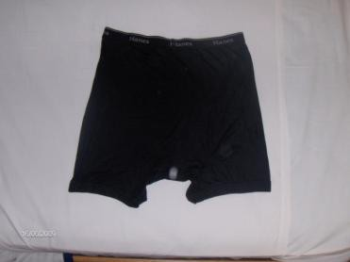

a. Lay flat with the front side facing down, waistband away from you.

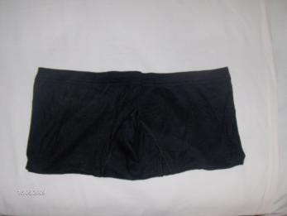

b. Fold in half from crotch to waistband. Crotch should be even with the top of the waistband. Fold excess over to make top even.

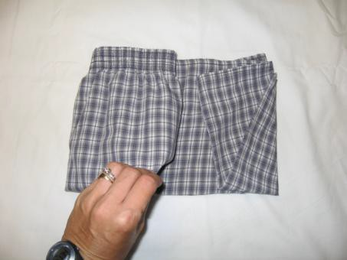

c. Square the garment by folding the sides in equal thirds neatly towards the center. Starting with the left side, fold one third of the garment from left to right. Then fold the right side over the left. Ensure you keep edges even as you fold. Excess material may be tucked in to square the edges.

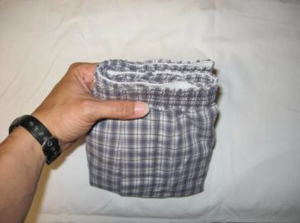

d. Turn the garment over (front facing up).When folded properly, there will be a single fold on the left. The open end will be to the right. Edges will be as even as possible.

**Bras/Sports Bras:**

Stack with the cups facing up. If you are displaying sports bras, they will be stacked underneath the regular bras.

**Instructions for Folding Bras**

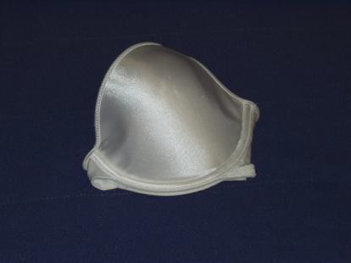

a. Place one cup inside the other cup. Make sure the single fold is on the left.

b. Tuck the straps and back of the bra completely inside the cups.

**Instructions for Folding Sports Bras**

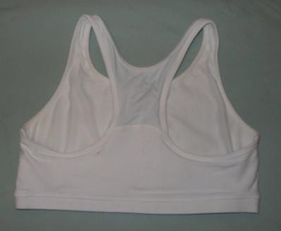

a. Lay the bra flat with the front down and the straps away from you.

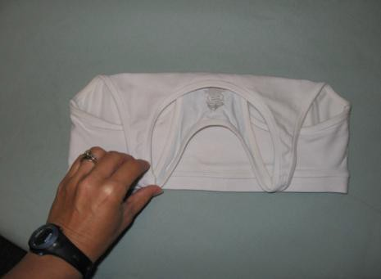

b. Fold the straps down until flush with the bottom edge of the bra.

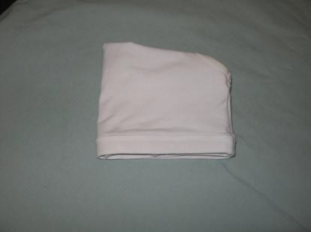

c. Fold the bra from left to right in half, keeping all edges even. Single fold will face the left.

**Socks:**

Roll socks in pairs.

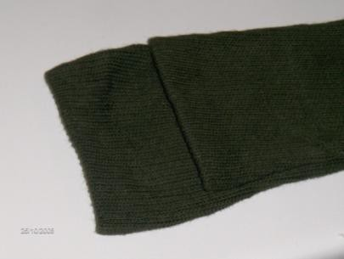

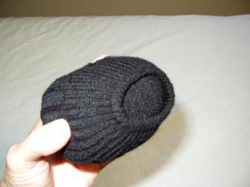

a. Lay a pair of socks flat (right side out), one on b. Turn the open end of the bottom

top of the other, and one sock offset by 2 inches. sock inside-out back over the entire

Starting with the toes, tightly roll towards the roll, securing it. The open end of the open end. socks will be flat with no excess

sticking out past the roll.

**Folding Instructions for Towels:**

NOTE: Used (damp) towels and washcloths should be hung neatly over the desk chair to air dry.

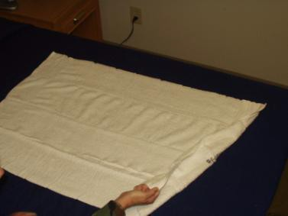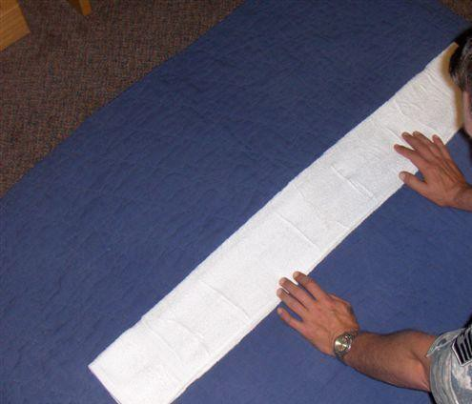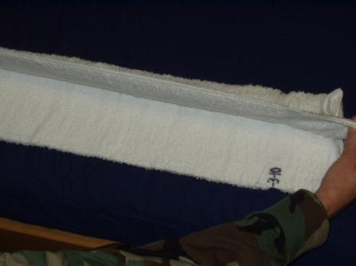

a. Lay the towel flat as shown. b. Fold the towel in half c. Starting from the end,

Take the edge closest to you lengthwise again, *toward* tightly roll the towel from left

and fold the towel in half you this time, so it is to right. When complete,

lengthwise, away from you, so approx. 6 inches wide. keep the edges as even as

it is approx. 12 inches wide. Keep the edges as even as possible.

possible, and smooth out

all wrinkles.

**Folding Instructions for Washcloths (Optional):** Lay the washcloth flat. Fold it in half from left to right, then in half from bottom to top away from you. Keep the edges as even as possible.

**Uniform/Clothing and Equipment Requirements**

Cadets must be properly fitted with uniforms pursuant to AFI 36-2903 and AFJROTC 36-2001 prior to arrival at the University of Houston. The items listed below are the minimum requirements necessary for attendance.

ITEM QUANTITY

Flight cap 1 Shirts/Blouses, Short Sleeve 3

Trousers/Slacks 2

Black Military Shoes 1 pair

Black Socks/Hosiery 4 pair

Cadet/**Staff Sergeant Rank** 2 pair

Name Tag 1

Ribbon Holder/Ribbons 1 set

Belt with Buckle 1

Undergarments/V-neck T Shirt 5 (min)

Sports Bra for Females (mandatory); Athletic Supporter for Men (optional) As needed

Athletic Shoes 1 pair

White Athletic Socks 4 pair Athletic Uniform (AFJROTC issued shirt/shorts or Unit issued shirt/shorts) 4 pair (min) Shower Shoes 1 pair

Towels (washcloths optional) 3

Notebook with Paper 1

Pens/Pencils 2

Personal Hygiene Kit (example: liquid/bar soap, razor, shaving cream, toothbrush) 1

Challenger CLC Cap (issued 1st day) 1

Laundry Bag 1

Hangers 6

Sheets (top sheet/fitted sheet combo OK—NOTE: sheet size is **TWIN X-LONG**) 1 set

Pillow, Pillow Case 1 each

Blanket 1

Eye Glasses Strap (if you wear glasses) 1

Sun Screen 1 tube

Hand Sanitizer 1

Clorox/Lysol Wipes 1 carton

Hydration System (Camelbak or equivalent) 1

Insect Repellent 1

**Inspections**

Cadets **will** visit the example room upon arrival. Note-taking at this room is highly encouraged so cadet rooms can be assembled in a quick and accurate manner. Rooms must be assembled in the exact same fashion as the example room, as this will be what inspectors use to grade.

Cadets will perform Open Ranks Inspections of their uniforms, and AFJROTC instructors will conduct room inspections simultaneously.

Each inspection will be graded and points will be added to determine awards.

**Inspection Procedures**

**OPEN RANKS**

The command is “**Open Ranks, MARCH**.” It is only given to a formation when in line at normal interval. The flight commander proceeds and aligns the flight. Once the flight is aligned, the flight commander commands “**Ready, FRONT**.” The flight commander takes one step forward and faces to the right in a position in front of the guide (or first element leader if there is no guide).

The flight commander salutes and reports to the inspector “**Sir (Ma’am), _____ Flight is prepared for inspection.”** As soon as the flight commander has been inspected, he or she is asked to accompany the inspector. The flight commander then executes a left face (down line) and commands “**Second, Third, and Fourth Elements, Parade, REST**.” The flight commander executes a half left in marching without arm swing and halts one pace to the right and one pace to the rear of the inspector (this causes the flight commander to precede the inspector). This position is maintained throughout the inspection of the front of each respective rank. When moving from individual to individual during the inspection, the inspector and flight commander simultaneously execute a face to the right in marching and an in-place halt.

**CLOSE RANKS**

After inspecting the entire flight, the inspector marches off to the right flank (element leaders) of the flight. The flight commander proceeds directly to a position three paces beyond the front rank, halts, faces to the left (down line), and commands “**Flight, ATTENTION**” The flight commander then takes one step forward with arm swing and faces to the right. The inspector marches to a position directly in front of the flight commander and gives comments. After receiving comments, the flight commander salutes. The flight commander then faces left (down line) and commands “**Close Ranks, MARCH**.” He or she then gives “**Parade REST,” “AT EASE,” or “REST”** (whichever is appropriate) and posts in front of and centered on the flight. The flight commander commands “**Flight, ATTENTION”** and “**FALL OUT.”**

**Management of the Cadet Corps**

The cadets in the intermediate leadership course will have numerous opportunities to manage their assigned flights during the camp. It is imperative you come prepared and ready to perform! Cadets must know how to lead and manage to meet mission demands. This hands-on experience affords you the opportunity to put the theories of previous leadership courses into practice. All directing and leading will be done by **you**. You will practice your communication, decision-making, and personal-interaction skills. The leadership and management principles outlined will be taught using the knowledge, comprehension, and application levels of learning.

**The ICLC course objectives are:**

1. Apply the theories and techniques learned in previous leadership courses.

2. Know the functions of management.

3. Know the difference between leadership and management and its impact on unit effectiveness.

4. Know how to develop leadership and management competency through participation.

5. Know the two principles of leadership behavior and four leadership styles.

6. Comprehend the primary factors of situational leadership.

7. Apply principles toward people, tasks, and the mission.

**Physical Fitness**

Morning Physical Training (PT) will be a whole-body workout. Generally, cadets should attain a level of fitness that allows the cadet to perform numerous flutter kicks, jumping jacks, lunges, isometrics, push-ups, sit-ups, and multiple levels of running. **CLC cadets are expected to be at an above-average level of fitness upon arrival.** They will go through a 45 minute physical training session each morning. Cadets MUST be in an approved PT uniform (AFJROTC or school issued shirts/shorts/athletic shoes). Females must have their hair pulled back (ponytail or braids are OK).

In addition to the regularly scheduled PT sessions, there will be a graded Fitness Test. This test will consist of 3 events for a total of 100 points, and the score will count as a component towards awards. The events are: one-mile run, one minute of push-ups, and one minute of sit-ups. **The MINIMUM requirement to be eligible for awards at CLC is to complete the one-mile run in 10 minutes or less.**

Cadets will also participate in evening sports activities. These activities are designed to build teamwork and self-discipline. They also promote spirit in competition, esprit de corps, stress relief, and a strengthened cardiovascular system.

For safety reasons, cadets need to abide by the following rules:

-If you feel ill, notify an instructor as soon as possible.

-Always have a full hydration system.

-Do not take part in any type of horseplay.

-Do not spit on or in the PT exercise/rest areas or running track.

**Instructors must ensure their cadets can handle PT requirements before bringing them to the course.** Cadets who have physical issues such as asthma, diabetes, recent surgeries, overweight, heart problems, or recent broken bones should have a letter from their personal physician stating they can participate in significant physical activity. Cadets unable to complete the rigors of the course will be sent home.

**Pass in Review**

Group Staffs: Position themselves.

Wing Adjutant: Takes position on the final line.

Flight Commanders: On the first note of Adjutant’s Call, bring their staffs to attention, execute an about face, and remain there until all elements within their flights are halted and aligned on the final line.

Squadron Adjutants: Come to attention and execute an about face with the commanders and move to the final line. They align on the adjutant, execute right face and remain in position until all units in their flight have halted on the final line. Then they rejoin the staff by the most direct route at adjutant’s cadence.

Flight Commanders: On the first note of Adjutant’s Call, come to attention, execute an about face, and call their flight to attention. Then in order of right to left in each squadron, command “**GUIDE ON LINE.”** Command “**Forward, MARCH”** (marching backwards); “**Flight, HALT**;” and **“COVER.”** Then face to the front.

Commander of Troops: Commander of Troops (COT) and staff march to their positions once all elements are aligned.

Wing Adjutant: On signal of the COT, moves to position by most direct route at adjutant’s cadence, halts, faces the final line, and commands “**GUIDES, POST”** and “**GIVE YOUR SQUADRONS PARADE REST.”**

Squadron Commanders: Command “**Parade, REST**.” (Flight commanders relay all preparatory commands given by squadron commanders).

Wing Adjutant: Commands “**In Place, SOUND OFF**.” On the completion of music, commands “**GIVE YOUR SQUADRON ATTENTION.”**

Squadron Commanders: Command “**Squadron, ATTENTION.”**

**PAY RESPECT TO THE FLAG**

Wing Adjutant: Commands “**GIVE YOUR SQUADRON PRESENT ARMS.”**

Squadron Commanders: Command “**Present, ARMS**.”

Commander of Troops: Commands “**Staff, Present, ARMS**.” The national anthem or To the Color is played. Commands “**Staff, Order, ARMS.”**

Wing Adjutant: Faces about, salutes, and reports “**Sir (Ma’am) the parade is formed.”**

Commander of Troops: Returns the salute and commands “**TAKE YOUR POST.”**

Wing Adjutant: Moves directly toward the COT, executes a 45-degree pivot while marching to the left, executes a 45-degree pivot while marching to the right, halts in position, and executes an about face.

Commander of Troops: Commands “**GIVE YOUR SQUADRON ORDER ARMS**.”

Squadron Commanders: Command “**Order, ARMS**.”

Commander of Troops: Commands adjutant to “**RECEIVE THE REPORT.”**

Wing Adjutant: Returns to original position, reversing the previous procedures, and commands “**REPORT.”**

Squadron Commanders: From adjutant’s left to right, report while saluting “**(A, B, etc.) Squadron, all present or accounted for, Sir (Ma’am).”**

Wing Adjutant: Returns the salute of each Squadron Commander, executes an about face, salutes, and reports “**Sir (Ma’am), all present or accounted for.”**

Commander of Troops: Returns the salute and commands “**PUBLISH THE ORDERS.”**

**OFFICERS CENTER**

Wing Adjutant: Faces about and commands “**ATTENTION TO ORDERS, DETAIL FOR TODAY_____________, by order of (Officer) ________________.”**

Officers and

Guidon Bearers: On the command “OFFICERS,” move forward the required number of paces. On the command “CENTER,” face the center and step off on the Command “MARCH.”

Flight Commanders: Face and step off at the same time as officers and guidon bearers.

First Sergeants: Assume the commanders’ positions.

Senior Squadron

Commander: Commands “**Forward, MARCH**,” then “**Officers, HALT**.” Officers present arms, and guidon bearers present guidons.

Commander of Troops: Commands “**Order, ARMS**,” then “**Officers, POST, MARCH.”**

Senior Squadron

Commander: Commands “**Officers, HALT,”** then “**POST, MARCH.”**

**PRESENTATION OF COMMAND**

Commander of Troops: Commands “**GIVE YOUR SQUADRONS PRESENT ARMS.”**

Squadron Commanders: Command “**Present, ARMS.”**

Commander of Troops: Commands “**Staff, Change Post, MARCH”** (may salute automatically after posting). Then commands “**Staff, Present, ARMS**.” Reports to reviewing officer “**SIR (MA’AM), I PRESENT THE COMMAND.”**

Reviewing Officer: Returns salute and commands “**MARCH THE COMMAND IN REVIEW.”**

Commander of Troops: Commands “**Staff, Order, ARMS;” “Staff, Change Post, MARCH**;” and “**GIVE YOUR SQUADRON ORDER ARMS.”**

Squadron Commanders: Command “**Order, ARMS**.”

Commander of Troops: Commands “**PASS IN REVIEW**.”

Squadron Commanders: Command “**Column of Flights, Right Flights, Right Turn, MARCH**.” (On the command Right Flights, Flight commanders face about).

Although all cadets selected for Cadet Leadership Course are the best at their school and are winners in their own right, some will excel and be recognized for their outstanding performance. Listed below are the awards given to those individuals and team members who rise to the top.

**Challenger CLC Awards**

**Commandant’s Award –** Presented to the number one cadet overall in all areas at Challenger CLC (academics, inspections, and physical training). This cadet is also entitled to the Superior Performance Ribbon with silver star at unit discretion.

**Superintendent’s Award –** Presented to the number two cadet overall in all areas at Challenger CLC (academics, inspections, and physical training). This cadet is also entitled to the Superior Performance Ribbon with bronze star at unit discretion.

**Distinguished Honor Graduate Award** - Presented to the next top five percent of graduates overall (academics, inspections, and physical training) after the two above awards. These cadets are also entitled to the Superior Performance Ribbon at unit discretion.

**Honor Graduate Award** - Presented to the next top ten percent of graduates overall (academics, inspections, and physical training) after the above awards.

**Outstanding Flight Award** - Presented to the overall outstanding flight with the highest cumulative average score in academics, inspections, and drill evaluation. These cadets are also entitled to the Outstanding Flight Ribbon at unit discretion.

**Flight Sports Competition –** Presented to the flight winning the Flight Sports Competition. These cadets are also entitled to the Health and Wellness Ribbon at unit discretion.

**Flight Drill Competition** - Presented to the flight winning the Flight Drill Competition. These cadets are also entitled to the Drill Competition Ribbon at unit discretion.

**Leadership School Ribbon -** Presented at unit discretion to all cadets satisfying CLC graduation requirements.

**Endeavour CLC Awards**

**Commander’s Trophy –** Presented to the cadet with the highest overall leadership evaluation from CTOs and peer group evaluation.

**Leadership School Ribbon –**Presented to all cadets that satisfy graduation requirements. Ribbon should be worn with 2 oak leaf clusters at unit discretion.

**Flight Sports Competition** **–**The winner of the Flight Sports Competition is recognized at the awards ceremony. These cadets are also entitled to the Health and Wellness Ribbon at unit discretion.

**Flight Drill Competition –**The winner of the Flight Drill Competition is recognized at the awards ceremony. These cadets are also entitled to the Drill Competition Ribbon at unit discretion.